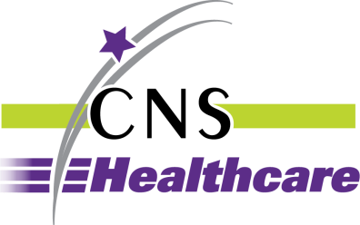

BARRIER REMOVAL/ACCOMMODATION REQUEST
FORM

Please type or print legibly.

Name of person making request: __________________________________ Date of request: __________

Address: ______________________________ City ___________________ State_____ Zip__________

Telephone Number______________________ Email address: _________________________________

If Person needing accommodation is not the individual completing this form, please enter:

Name: ______________________________________Telephone Number: ________________________

Other Contact Information: _____________________________________________________________

Check one: Accommodation Barrier Removal

Accommodation needed or location of barrier: ______________________________________________

____________________________________________________________________________________

Brief statement of why the accommodation is needed or the barrier removed: _____________________

____________________________________________________________________________________

____________________________________________________________________________________

Date accommodation is needed: _________________________________________________________

Signature: _______________________________________________ Date: ______________________

Please send the completed form to the Human Resources Department at the address below or by email via the Department’s confidential email address to hrconfidential@cnshealthcare.org.

Human Resources
24230 Karim Blvd., Ste. 100
Novi, MI 48375

Upon request, reasonable accommodation will be provided in completing this form or copies of the form will be provided in alternative formats.

Rev. 8/3/21

