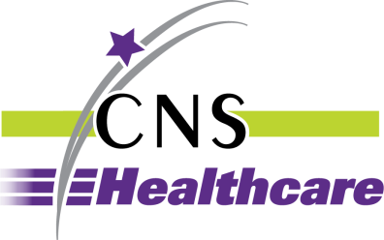

BARRIER REMOVAL/ACCOMMODATION REQUEST
FORM

Please type or print legibly.

Name of person making request: __________________________________ Date of request:__________

Address: ______________________________ City ___________________ State_____ Zip__________

Telephone Number______________________ Email address: _________________________________

If Person needing accommodation is not the individual completing this form, please enter:

Name: ______________________________________Telephone Number:________________________

Other Contact Information: _____________________________________________________________

Check one: Accommodation Barrier Removal

Accommodation needed or location of barrier: ______________________________________________

____________________________________________________________________________________

Brief statement of why the accommodation is needed or the barrier removed: _____________________

____________________________________________________________________________________

____________________________________________________________________________________

Date accommodation is needed: _________________________________________________________

Signature: _______________________________________________ Date: ______________________

Please send or email the completed form to Robin Spivey, Chief Human Resources Officer:

24230 Karim Blvd., Ste. 100
Novi, MI 48375
rspivey@cnshealthcare.org or hrconfidential@cnshealthcare.org

Upon request, reasonable accommodation will be provided in completing this form or copies of the form will be provided in alternative formats.

Rev. 1/2/18

